3GPP TSG RAN WG1 #125 R1-2604242
Dalian, China, May 18th ~ 22nd, 2026

Agenda item: 10.8.1
Source: Lenovo
Title: Views on ISAC evaluations
Document for: Discussion and decision

Introduction
In TR 38.914, it has been agreed to at least support sensing use cases of detection and/or tracking of passive objects and communication assistance, which has been also confirmed as the working assumption for the performance evaluation in RAN1#124bis [1].
Working assumption:
For Rel-20 6G ISAC performance evaluation,
- evaluate object detection and/or tracking for the following sensing targets/objects: UAV, human, vehicle, AGV
- discuss further on evaluation on communication assistance

Conclusion
For Rel-20 6G ISAC evaluation, the attributes (e.g. antenna pattern, mobility, etc.) of different UEs are for the purpose of evaluation discussion. No intention to study or specify diverse device type.
In this document, we continue sharing our views on the related aspects for evaluation, including the evaluation and sensing mode specific assumptions, performance evaluation metrics, communication assistance use cases and necessary extension of channel model.

General evaluation assumptions

Baseline evaluation assumptions
In RAN1#124bis, some combinations of the sensing target and scenarios have been agreed with some potential carrier frequencies[1].
Agreement:
For Rel-20 6G sensing performance evaluation of object detection and/or tracking, the following cases/combinations are considered as baseline cases/combinations.
Sensing target | Indoor or outdoor | Scenario | Carrier frequency
UAV | Outdoor | UMa-AV, SMa | 4 GHz, ~7 GHz, 30 GHz (for UMa-AV only)
Human | Outdoor | UMa | 4 GHz, ~7 GHz, 30 GHz
 | Indoor | Indoor Hotspot | 4 GHz, ~7 GHz, 30 GHz
Vehicle | Outdoor | Urban Grid, Highway | 4 GHz, ~7 GHz, 30 GHz (for Urban Grid only)
AGV | Indoor | Indoor factory (SH) | 4 GHz, ~7 GHz, 30 GHz
- Note: sensing mode(s) for each row will be discussed
- Other cases/combinations can also be evaluated, reported and collected from companies.
Note: In this agreement, no intention to de-prioritize other scenarios or carrier frequencies.
In addition to the carrier frequency, for the sensing performance evaluation, it is preferred to follow the same underlying communication scenario assumptions and parameters in 6GR, including, e.g., system bandwidth, layout (cell/sector definition), ISD, antenna configurations of UE and BS, antenna mechanical and electrical tilt, UE dropping, traffic pattern, etc.
This is motivated to comply with the motivation and functionality of integrated communication and sensing operations and evaluations without imposing additional sensing specific deployment costs in 6G RAN.
- Using the same scenario assumptions and parameters for communication as the baseline to define sensing deployment scenarios, including system bandwidth, cell/sector layout, ISD, antenna configurations of UE and aNB, UE dropping and traffic model.
Nevertheless, additional sensing-related definitions are required for sensing evaluation, which can be added on top of each deployment scenario per-sensing use-case/scenario and/or per-target type. The additional sensing-specific parameters include at least the following:
- TRPs and UEs operating as the STX and/or SRX node(s)
The sensing Tx/Rx nodes, either TRP or UE, can be pre-selected as part of the scenario definition or dynamically selected from the dropped/defined nodes within a scenario.
- Sensing target related parameters
The parameters at least include target type (e.g., UAV, human, AGV), physical characteristics (e.g., size, RCS), 3D distribution, 3D mobility, orientation, LOS/NLOS condition and other assumptions on the relationship with communication UEs.
- Channel modelling features
In some scenarios, some of the channel behavior or modelling elements are necessary for sensing evaluations and may not be treated as optional as communications, since they impact sensing performance considerably, e.g., spatial consistency modelling, blockage modelling, low-power/mobile clusters, ground reflection, etc. Such effects need to be defined as part of the deployment or assumptions for each sensing scenario.
- Known/deterministic environment objects (EO’s)
The EOs can be considered as part of a deployment scenario when available, e.g., EO Type-2’s and EO Type-1’s as defined in Section 7.9.0 of TR 38.901, due to the potential impact on the sensing performance evaluations.
Thus, all of these sensing-specific parameters above need to be considered, discussed and defined in the deployment scenarios for sensing evaluations.
- Determine sensing Tx/Rx node selection, sensing target related parameters (i.e., type, size, 3D mobility, 3D distribution, orientation and LOS/NLOS), known/deterministic environment objects and necessary channel modeling features as additional parameters for each sensing scenario definition.
Note that the scenarios for sensing use cases defined in NR Rel-19 are all based on the communication scenarios, though they are used for channel model calibration. Since the types of passive objects to be detected and/or tracked via sensing in 6G include UAV, human, vehicles and AGVs, which have been also discussed in NR in the ISAC as introduced above, all of the deployment scenarios defined in TR 38.901 can be used as the starting point for further updating.
- The scenarios defined in Section 7.9.1 for ISAC in TR 38.901, i.e., ISAC-UAV, ISAC-Human, ISAC-Automatic and ISAC-AGV, can be used as the starting point for necessary updating for the use case of detection and/or tracking of passive objects.

Sensing modes for each use case
Though all six sensing modes have been agreed for study, it is not necessary and realistic to study and evaluate all these modes for each use case. To avoid redundant work, we suggest to study some sensing modes for each use case, and potentially cover all modes for all the use cases. The considerations to down select the sensing modes for each use case include:
- Typical deployment scenarios
Referring to the sensing use case descriptions in [2], the typical deployment scenarios with sensing targets of UAVs, human, vehicle and AGVs can be considered to involve TRP and/or UE in the sensing operation.
For example, UAVs as the sensing target always have specific locations, i.e., high altitude in outdoor, which can be straight forward to consider TRP monostatic or TRP-TRP bistatic sensing mode. For the use cases with vehicle as the sensing target, the TRP, UE-type RSU and vehicle-type UE can be used as the sensing Tx or Rx, which means the TRP monostatic, TRP-UE bistatic, UE-TRP bistatic and UE monostatic sensing modes can be considered.
- Expected sensing performance
To satisfy the sensing performance requirements, e.g., detection rate, position estimation accuracy, the nodes selected for sensing could potentially provide better performance.
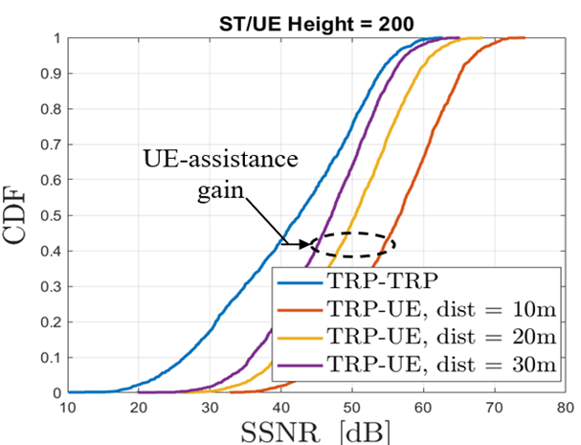
Figure 1 Illustration of advantage of UE assisted sensing for proximity sensing
For example, in case of proximity sensing/collision avoidance as discussed in Section 5, we evaluate the sensing SNR of the TRP-TRP bi-static sensing mode and TRP-UE bi-static sensing mode as illustrated in Figure 1, which shows than for the proximity detection via sensing, the TRP-UE bi-static sensing mode has potential to obtain a higher Sensing SNR.
Accordingly, for the use cases of detection and/or tracking of passive objects with different target types, we recommend the sensing modes as summarized in Table 1.
Table 1 Recommended sensing modes for each use case
Sensing target | Indoor or outdoor | Recommended sensing modes
UAV | Outdoor | TRP mono-static, TRP-TRP bi-static
Human | Outdoor | UE-TRP bi-static, TRP-UE bi-static
 | Indoor | UE-TRP bi-static, TRP-UE bistatic, TRP-TRP bi-static, UE-UE bi-static
Vehicle | Outdoor | UE-TRP bi-static, TRP-UE bi-static, UE mono-static
AGV | Indoor | UE-TRP bi-static, TRP-UE bistatic, TRP-TRP bi-static, UE mono-static
Thus, we have following proposal for the use cases with different sensing targets together with the corresponding scenarios.
- To avoid redundant work, RAN1 to select some typical sensing modes in each use case, considering the typical application scenarios and expected performance, as indicated in the below table by adding a new “Recommended sensing mode” column to the RAN1#124bis agreed case/combinations table:
Sensing target | Indoor or outdoor | Recommended sensing modes
UAV | Outdoor | TRP mono-static, TRP-TRP bi-static
Human | Outdoor | UE-TRP bi-static, TRP-UE bi-static
 | Indoor | UE-TRP bi-static, TRP-UE bi-static, TRP-TRP bi-static, UE-UE bi-static
Vehicle | Outdoor | UE-TRP bi-static, TRP-UE bi-static, UE mono-static
AGV | Indoor | UE-TRP bi-static, TRP-UE bi-static, TRP-TRP bi-static, UE mono-static
From RAN1 aspect, it is necessary to design the physical functions and procedure to support sensing with satisfying performance. Thus, the cooperative/multi-static sensing mode/operation, considering multiple nodes and sensing modes, is of high interest, given the possibility of re-using sensing signal(s) for multiple measurements, leading to increased energy efficiency and measurement diversity/accuracy, which also opens a synergy among TRP/network-based sensing operations as well as UE assistance, when available.
- The cooperative and multi-static sensing modes with multiple nodes, and potentially involving multiple/combined sensing modes, need to be studied for all use cases.

Sensing mode specific assumptions
In RAN1#124bis, some sensing mode related evaluation assumptions on some parameters have been agreed as the starting point with some example values[1].
Agreement:
Companies are encouraged to bring input to the sensing mode related evaluation assumptions in next meeting, using the following table as starting point. The values in current table are example values based on the input and discussion in RAN1#125.
Note: This is not intended to specify all sensing modes.
Note2: This does not mean any sensing mode is applicable to any scenario/use case.
Note3: Other parameters/values for each sensing mode can also be discussed.
Sensing mode | Parameter | Value
TRP mono-static | Sensing Tx/Rx operating simultaneously or not | Simultaneously, or not simultaneously (FFS: with/without switching time and value if any)
 | BS antenna isolation | - For Around 7 GHz and below 7 GHz:  - Option 1: 80 dB  - Option 2: 65 dB  - For 30 GHz:  - Option 1: 100 dB  - Option 2: 72 dB  - Option 3: 85 dB
 | BS transmit power | - Simultaneously: min {BS transmit power in Table of ISAC system configuration, BS Rx saturation power + BS antenna isolation}, assuming the BS Rx saturation power = -28 dBm  - Not simultaneously: Follow BS transmit power in the table of general evaluation assumption
 | BS self-interference impact | The residual leakage interference/noise is modelled e.g., by additional additive white Gaussian noise, -174 + 10log₁₀(BW) + X dBm in BW Hz, BW is simulated bandwidth, X = {-Infinity, 0, 5} is up to company report.  Note: X = -Infinity corresponds to not modelling self-interference.
UE mono-static | UE type for sensing | Companies to report
 | Sensing Tx/Rx operating simultaneously or not | FFS
 | UE transmit power | FFS
 | UE Antenna isolation | FFS
 | UE Self-interference impact | FFS
 | Availability of UE location, velocity and orientation | - Option 1: Known, ideally (baseline)  - Option 2: Known, with error. FFS distribution of error in each aspect (e.g. location, speed, orientation).  - Option 3: Unknown, rely on actual measurement  Note: UE location, velocity and orientation are individually determined
TRP-TRP bi-static | Timing/frequency error | - Option 1: Ideal (baseline)  - Option 2: With error, FFS value range and model of the distribution  Note: timing error and frequency error are individually determined
 | Coherency and phase continuity among symbols within a CPI | - Option 1: Always coherent  - Option 2: Coherency is assumed under some conditions; FFS: Conditions
UE-UE bi-static | UE type for sensing | Companies to report
 | Timing/frequency error | - Option 1: Ideal (baseline)  - Option 2: With error, FFS value range and model of the distribution  Note: timing error and frequency error are individually determined
 | Availability of UE location, velocity and orientation | - Option 1: Known, ideally (baseline)  - Option 2: Known, with error. FFS distribution of error in each aspect (e.g. location, speed, orientation).  - Option 3: Unknown, rely on actual measurement  Note: UE location, velocity and orientation are individually determined
 | Coherency and phase continuity among symbols within a CPI | - Option 1: Always coherent  - Option 2: Coherency is assumed under some conditions; FFS: Conditions
TRP-UE bi-static | UE type for sensing | Companies to report
 | Timing/frequency error | - Option 1: Ideal (baseline)  - Option 2: With error, FFS value range and model of the distribution  Note: timing error and frequency error are individually determined
 | Availability of UE location, velocity and orientation | - Option 1: Known, ideally (baseline)  - Option 2: Known, with error. FFS distribution of error in each aspect (e.g. location, speed, orientation).  - Option 3: Unknown, rely on actual measurement  Note: UE location, velocity and orientation are individually determined
 | Coherency and phase continuity among symbols within a CPI | - Option 1: Always coherent  - Option 2: Coherency is assumed under some conditions; FFS: Conditions
UE-TRP bi-static | UE type for sensing | Companies to report
 | Timing/frequency error | - Option 1: Ideal (baseline)  - Option 2: With error, FFS value range and model of the distribution  Note: timing error and frequency error are individually determined
 | Availability of UE location, velocity and orientation | - Option 1: Known, ideally (baseline)  - Option 2: Known, with error. FFS distribution of error in each aspect (e.g. location, speed, orientation).  - Option 3: Unknown, rely on actual measurement  Note: UE location, velocity and orientation are individually determined
 | Coherency and phase continuity among symbols within a CPI | - Option 1: Always coherent  - Option 2: Coherency is assumed under some conditions; FFS: Conditions

In the table, the parameter of “UE type for sensing” needs for clarification from evaluation assumption aspect for better comparison and consistency amongst difference scenarios and assumptions. Thus, we suggest using more concise descriptions, such as the antenna array configurations, antenna orientations and mobility assumptions for the UE selected for sensing operation.
- Define the evaluation parameters of the UE for sensing operation, e.g., antenna array configurations, orientations, locations, mobility, instead of using the term of “UE type” in the table.
For TRP mono-static sensing, when the Sensing Tx/Rx is not operating simultaneously, the Tx-Rx switching time needs to be considered for the sensing performance evaluation, especially on the coverage. In particular, the non-zero switching time leads to a blind sensing area with a short delay spread. The switching time limitation is defined in TS 38.104 as shown in Figure 2.
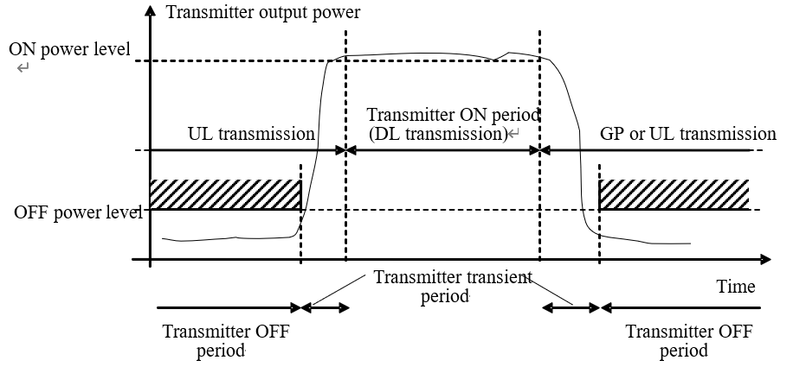
Figure 2 The Tx-Rx switching time limitation defined in TS 38.104
The switching time appears as a limiting factor for the targets within 1.5km distance from the TRP, and hence shall be taken into account if the time-domain pulse-wave signals are used as part of the evaluations. For example, as a starting point, companies can consider reporting from the following set of values of switching time: {0 µs (ideal), 7 µs, 10 µs} consistent with the bound in TS 38.104 (≤ 10 µs for FR1).
- For both mono-static sensing modes, the switching time should be considered if Sensing Tx/Rx are not operating simultaneously.
Considerations on coherence and phase continuity among the symbols within a CPI have been agreed as an evaluation assumption for all bi-static sensing modes. From an end-to-end sensing measurement perspective, phase coherence is impacted both from the transmitter and receiver side assumptions. Thus, the separate consideration on the Tx and/or Rx phase coherence is meaningful, as they both lead to the impaired phase continuity across multiple symbols, while impacting the system performance and related countermeasures in different ways.
- When phase continuity over multiple symbols of a CPI is not available, assumptions of phase coherence are treated separately for the sensing transmitter and receiver nodes.
In FL’s summary, there are some questions on the evaluation assumptions of UE mono-static sensing mode as also indicated as FFS in the table as copied below[3].
[FL2][H] Question 6.3-2-2
For companies who would like to evaluate UE mono-static, FL encourage you to share your views on the following question.
- What’s the assumption of UE RF/BB component to support full-band-full-duplex for UE mono-static?
  - For example, for a UE with 1T4R, does it mean 3 Rx antenna (other than the Tx one) can do reception when performing mono-static sensing? Or only half antennas (i.e. only 2 Rx) can receive signal?
- What’s the assumption of UE self-interference isolation?
  - Is this value different for different UE type? For example, does CPE UE have higher isolation capability than handheld UE?
- Can such kind of UE support full-band-full-duplex for communication, if they can support UE mono-static sensing?
  - If no, what’s the reason?
We think the reasonable parameters should be assumed for such sensing mode, especially on the self-interference isolation and support of full-duplex. Therefore, it would be beneficial to receive RAN4 inputs/feedback on at least (i) full-band full-duplex feasibility per UE class (handheld, CPE/FWA, vehicle, RSU); (ii) Tx-Rx antenna isolation values at 4 GHz, ~7 GHz, 30 GHz; (iii) Tx-Rx switching time when Tx and Rx are not simultaneous. The RAN4 LS questions is targeted to inform the FFS entries in the RAN1#124bis sensing-mode evaluation-assumption table.
- For UE mono-static sensing mode, RAN1 to send an LS to RAN4 on the assumptions and parameters of support full-band-full-duplex, antenna self-interference isolation and Tx-Rx switching time.

Performance evaluation
For the previous ISAC-related studies, the objectives of performance evaluation are different. For example, the purpose of evaluation in the ISAC channel modeling study is to calibrate channel modeling on the newly introduced features, e.g., RCS. The objective of evaluation in the NR ISAC study is to evaluate the performance of gNB-based mono-static sensing (i.e., single TRP with co-located sensing transmitter and receiver) for UAV use case without any UE impact. However, in this study, the physical layer functions and related procedure to support sensing in 6GR will be studied, which needs to be assessed via evaluation in different scenarios.
Note that the sensing-related requirements have been captured in TR 38.914 as copied below.

5.1.17 Sensing-related requirements
Sensing-related capabilities are measured in terms of the following technical performance requirements:
• Detection Probability and False Alarm Probability: Detection probability is the probability of correctly detecting the presence of the sensing target when it is present, and false alarm probability is the associated probability that a sensing target is detected when no corresponding true sensing target is present.
• Horizontal/Vertical Localization Accuracy: It is defined as the absolute difference between the estimated horizontal/vertical location and the actual horizontal/vertical location of the sensing target. The value of localization accuracy shall be obtained assuming 90% confidence level, which is the 90th percentile point of the CDF of the location estimation error. Both the horizontal and vertical localization accuracy are estimated based on Cartesian coordinates.
• Velocity Accuracy: It is defined as the absolute difference between the estimated velocity and the actual velocity of the sensing target. The value of velocity accuracy shall be obtained assuming 90% confidence level, which is the 90th percentile point of the CDF of the velocity estimation error.

As discussed in the FL summary (Section 7.1) [3], the sensing performance metrics defined in TR 38.914 for detection and/or tracking (e.g., missed detection probability, false alarm probability, positioning accuracy, and velocity accuracy) remain applicable as inclusive evaluation metrics for Rel-20 ISAC.
However, for meaningful and consistent evaluation results, additional clarification is required on how these existing metrics are interpreted and aggregated under different sensing conditions. In particular:
- when sensing targets are modeled with multiple scattering points, the statistics of the performance metrics are to be collected and reported per physical target/object rather than per scattering point;
- for tracking evaluations, the existing detection and estimation metrics can be reused, provided that the corresponding false alarm and missed detection statistics are defined consistently across time and across multiple targets..
Note that the definition of the false alarm in TR 38.914 just describes the case where a target is falsely detected within an environment where no sensing target exists. Nevertheless, this definition does not directly facilitate a metric for a false alarm when multiple targets being present.
- The current false-alarm definition present in TR 38.914 does not capture the case that an object is detected but not associated with any true target, where at least one (or multiple) target is present.
In the presence of multiple targets, it is relevant to capture both when a target is detected at the absence of all targets, or at the presence of other targets (e.g., target mismatch due to positioning error). In TR 38.765, two false alarm probability types are defined as copied below [4]:

4.1 Definitions of performance metrics
…
- False alarm probability Type 1 is defined for cases without true target dropped in simulation area. An object is detected when there is no target present in simulation area is considered a false alarm.
$$P_{f1}=\frac{\sum_{n=0}^{N-1}{Q_{n}}}{N}$$
where,
- $Q_{n}$ equal to 1 if at least one object is detected when there is no target dropped in the simulation area in the drop n, otherwise $Q_{n}$ equal to 0.
- $N$ is the total number of drops without targets in the simulation area.
- False alarm probability Type 2 is defined for cases with true target dropped in simulation area. An object is detected but not associated with any true target in the simulation area is considered as a false alarm.
$$P_{f2}={\sum_{\begin{aligned}0≤n<N \\ M_{n}^{'}≠0\end{aligned}}{\frac{D_{n}^{'}}{M_{n}^{'}}}}/K$$
where,
- $D_{n}^{'}$ is the number of detected objects but not associated with any true targets in the drop n.
- $M_{n}^{'}$ is the total number of detected objects in the drop n.
- $K$ is number of drops with at least one detected object.
The second type of false alarm probability has been defined in the NR-ISAC study for this purpose, which can be re-used for the follow-up 6GR evaluations:
- RAN1 considers definition of false alarm probability types in TR 38.765 to cover both conditions with no target and multi-target being present scenarios.
Regarding the sensing latency and refreshing rate, both these metrics are informative KPIs of the 6GR sensing from four aspects.
Firstly, they both describe timing requirements for delivery of sensing results, as also captured in the TR 22.137 sensing service KPI definitions. Although the sensing latency is further dependent on the system operation beyond RAN, it is envisioned that the sensing measurement process to occupy a long time window, which may effectively contribute to the sensing latency (e.g., coherent processing interval of 20-100ms is considered in the NR ISAC evaluations study).
Secondly, the sensing service latency and refresh rate effectively impact the sensing resource overhead, i.e., whether each simulated sensing drop shall deliver the sensing results in 10 or 100ms, define the ratio of resources that are consumed by the sensing operation, when present.
Thirdly, target-tracking, already agreed at RAN1#124bis, requires defining a refresh rate at least as according to the simulation assumption. Target-tracking inherently requires consecutive measurements at a known cadence and without an agreed refresh rate, statistics such as time-evolution of position/velocity error, trajectory continuity, and per-update missed-detection will be challenging to align across companies’ evaluations.
Fourthly, in the context of sensing-assisted communication, aspects such as sensing-assisted beam management and sensing-assisted mobility/handover are only meaningful when the sensing measurement remains valid at the moment it is applied, i.e., the sensing-acquisition-to-communication-action latency must be shorter than the relevant channel/scenario coherence time set by target mobility (e.g., ms-scale for vehicular, sub-second for pedestrian). Without an explicit latency bound, comparable evaluation across companies will be difficult.
- Sensing latency and refreshing rate are both informative metrics of the sensing capability, both in terms of the service KPI, as well as the resulting measurements overhead when sensing operation is present.
As such, it is motivated to capture the latency and refresh rate as description of the 6GR sensing capability for the RAN1 evaluation.
- RAN1 considers sensing latency and refreshing rate as part of the sensing KPIs.
Furthermore, from co-existence perspective, the performance evaluation of either communication or sensing needs to consider the radio resource multiplexing scheme and any potential interference and/or mutual synergy between them, which can be evaluated via the overhead.
- The evaluation of the sensing performance needs to consider the radio resource multiplexing scheme and any potential interference or mutual impact with communication evaluation.

Sensing assisted communication
In RAN1#124bis, it has been agreed to further discuss the evaluation on communication assistance in this meeting, including the necessity and related metrics[1].
Agreement:
Companies are encouraged to bring input to the evaluation on communication assistance in next meeting, including but not limited to:
- Necessity of evaluation on communication assistance
- For proponents, provide: what to sense and, if necessary, what/how to assist communication
  - What metric of sensing is to be defined
  - Whether/what metric related to communication is to be defined
  - Whether performance target/KPI is to be defined, for either sensing metric or communication metric
  - Necessary channel model extension
  - Necessary update of evaluation methodology on top of 5G NR sensing evaluation methodology
Sensing assisted communication includes all scenarios, wherein the sensing operation can assist in facilitating and/or improving communication-specific KPIs. In particular, we envision the following possibilities for sensing assisted communication.
Case 1: Environment-centric sensing-assisted communication.
Environment-centric sensing-assisted communication includes the scenarios where sensing operation assists to obtain information from the surrounding environment and thereby facilitates a rich prior information on the channel and the expected radio environment.
The obtained prior information can be hence utilized for the purpose of enhancing/optimizing communicating performance, including beam management, handover, etc. examples of this case include sensing-assisted development of a network digital twin, at least by identifying the main building structures in an urban environment.
It is worth mentioning that study of sensing-assisted communication via accumulation of RF environment map leads to additional study efforts specific to channel modeling (e.g., modeling walls and other related structures as sensing target with additional modeling accuracy), as well as the study/evaluation of how and how much the specific digital twin information can assist communication performance.
- Environment-centric sensing-assisted communication requires additional study efforts in terms of channel modeling as well as the identification & evaluation of the additional environment information types on the communication performance enhancements
Thus, for this case, the aspects of KPIs, channel model enhancement and necessary update of the evaluation methodology can be summarized in Table 2 below.
Table 2: Environmental Reconstruction Metrics
New sensing metrics | New target KPI | Channel model extension needed? | Evaluation methodology update needed?
Environment reconstruction accuracy | 10 cm – 1 m per-point | Yes, such as multiple points reflection modeling | Yes, at least dropping of static objects, sensing time assumptions.
Case 2: Target-centric sensing-assisted communication.
While sensing primarily considers a target as a physical object without a UE identity/function, sensing operation may also be applied to the physical objects associated (e.g., attached to) a UE device, which may benefit mutually, i.e., sensing may benefit from the additional information and/or measurements provided from the UE device, and at the same time, the UE benefits from the sensing input via monitoring/tracking environment and UE mobility.
As such, when the UE device is further attached to a physical object, the sensing of the said sensing object (e.g., sensing of the reflection of the DL signals towards the said UE), would inform network of the UE’s position, mobility, as well as the potential link conditions (e.g., LOS/NLOS, blockage, pathloss, etc.) with respect to existing radio nodes/TRPs.
This scenario is distinct from the above environment-centric assistance, as the target of the sensing operation is not the background/environment channel, but the UE itself (as a physical passive object co-located with the said UE).
- When a UE device is attached to a physical object, sensing of the attached passive object facilitates observing the UE’s mobility, blockage condition, and potential link LOS/NLOS identification or pathloss status towards the involved TRPs.
Thus, for this case, the aspects of KPIs, channel model enhancement and necessary update of the evaluation methodology can be summarized in Table 3 below.
Table 3: Target-centric sensing-assisted communication
New sensing metrics | New target KPI | Channel model extension needed? | Evaluation methodology update needed?
No | No | No | Yes, such as to define co-location of a passive target and a dropped UE according to the UE type
Case 3: Signal-centric sensing-assisted communication.
The signal-centric assistance includes all instances wherein a sensing-specific signal can be opportunistically used for communication purposes, e.g., to convey useful information, beam management, or for facilitating CSI measurement by a UE not necessarily associated with the sensing operation. As such, it is of interest to identify related scenario and use-cases wherein such sensing signal re-use can be gainful.
Thus, for this case, the aspects of KPIs, channel model enhancement and necessary update of the evaluation methodology can be summarized in Table 4 below.
Table 4: Signal-centric sensing-assisted communication
New sensing metrics | New target KPI | Channel model extension needed? | Evaluation methodology update needed?
No | No | No | Yes, such as to define communication evaluation setup given sensing signal transmissions
Therefore, for the sensing-assisted communication use cases, we have following proposal.
- RAN1 to consider the following categories for identifying scenarios of sensing-assisted communication use cases:
  - Case 1: Environment centric sensing assistance, wherein the sensing measurements are used to obtain information of the static and/or dynamic components of the communication propagation environment.
  - Case 2: Target centric sensing assistance, wherein the sensing measurements conducted from the passive object attached or collocated with a UE reveal communication relevant information of the UE.
  - Case 3: Signal centric sensing assistance, wherein the sensing signals are opportunistically used for obtaining communication relevant CSI measurements.
Within the proposed categories above, we suggest studying at least the evaluation methodology and achievable performance for target-centric sensing assistance
- RAN1 to study at least the evaluation methodology and achievable performance for target-centric sensing assistance for communication

Other sensing assistance
In addition to sensing-assisted communications, we understand that communication-assisted sensing can be also considered, and motivated as a mechanism to perform an energy efficient sensing operation by utilizing communication signals. Furthermore, when applicable, sensing measurements can be combined with positioning measurements of a UE device to enhance positioning performance of the said UE.
- Communication-assisted proximity sensing
As part of the object detection and tracking class of sensing use-cases, the scenarios of proximity sensing including a sensing area within a proximity of a UE device is of interest, e.g., for collision avoidance as well as the monitoring (health/presence) use-cases. In such scenarios, the UE device has the advantage of the favorable relative position to the target, to enhance the effective sensing SNR of the desired (sensing) reflective path.
As indicated in our contribution [5], the preliminary evaluation results on the Sensing path SNR (SSNR) illustrate the potential for gainful use of the TRP-UE and/or UE-TRP sensing modes, enjoying the short target-sensing entity pathloss from the UE side. The associated DL or UL physical shared data channels can be opportunistically used to obtain sensing measurements without additional signal overhead.
- Study potential scenarios and feasibility for communication data-assisted sensing use cases, e.g., proximity sensing, wherein a transmitted physical data/control channel is used for sensing by a sensing receiver.
- Target positioning based on physical downlink channel
In various scenarios, a UE device is attached to a passive physical object with (at least partially) known physical characteristics, which can be potentially considered as a sensing target. One such example is when a vehicle e.g., an AGV or a car, are also acting as a UE device which are associated/attached to the said vehicle as a physical object.
In such scenarios, the physical channel transmission between the said vehicle and the serving TRP can be utilized for sensing the reflected/scattered RF wave off the attached physical object, and thereby obtaining sensing information related to the object’s pose, position and/or mobility pattern. Such information can be utilized both for sensing-related purposes for the attached physical object (to determine characteristics of the attached vehicle), and further, may be utilized for the purposes of communication enhancements, including beam management and/or handover prediction or determination, based on the determined UE/object position and mobility pattern.
As indicated in our contribution [5], sensing an AGV attached to a UE, with association to the first TRP (as the serving network node), is facilitated via measurements of the neighbor TRPs from the reflective DL signal of the TRP-UE link, with the resulting positioning performance as depicted in Figure 3 below.
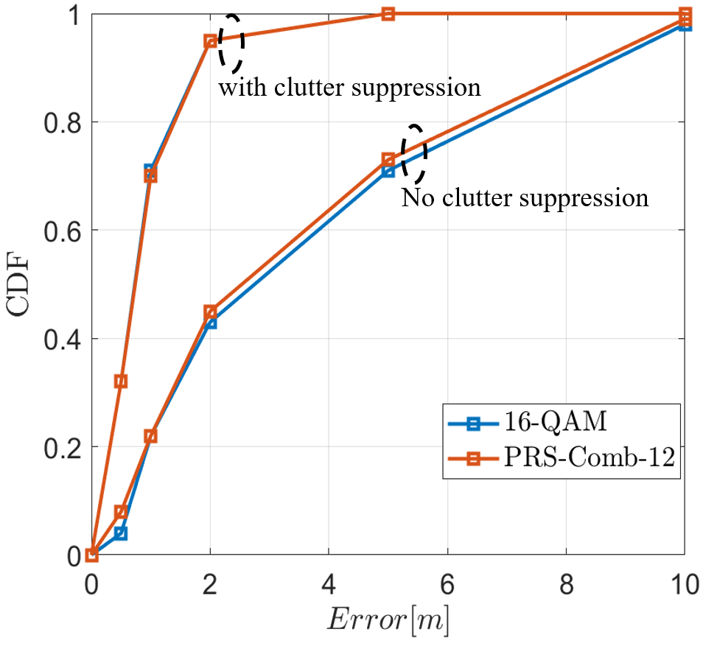
Figure 3 Positioning performance of single symbol transmission of DL data within the full band vs. PRS (Comb 12)-based positioning.
It can be observed from the evaluation result that with the sensing assistance, the positioning performance can be well improved via clutter suppression. More detailed assumptions and results can be found in our contribution [5].
- RAN1 to study performance of TRP-based target positioning based on sensing measurements using PDSCH transmission as a sensing signal.

Channel model extension
Similar to the evaluation on the transmission schemes, especially the reference signal design for the communication schemes, the link level channel model is always needed to evaluate and compare designs as for sensing. Thus, it is necessary to extend the ISAC channel model to support link level evaluation.
- Consider supporting link level channel modelling with some typical assumptions on parameters, e.g., to facilitate the evaluation on the reference signal designs and waveform.
As it has been observed from [6], the mobile scatterer effect of the background may lead to notable degradation of sensing performance, as it leads to high false alarm rate (type#1 and type#2). As such, in some scenarios, some of the channel behavior or modelling elements are necessary for specific sensing evaluations and may not be treated as optional, as (unlike communications) they impact the sensing performance considerably, e.g., spatial consistency modelling, blockage modelling, low-power clusters, ground reflection, etc. Such effects can be defined as part of the deployment or assumptions for each sensing scenario.
- Consider the impact of the background interference, including low-power clusters and mobile scatterer effect in the system level evaluations, at least for the outdoor scenarios.
In addition, the known/deterministic environment objects may be present in a specific deployment scenario (e.g., wall structures in an Urban grid scenario) which can be considered as part of a deployment scenario when available, e.g., EO type-2’s and EO type-1’s.
- Study the ISAC channel model extension to at least support following features, e.g., mobile clusters modeling in different scenarios, Type-1 EO modelling.

Conclusion
The observations and proposals on the ISAC evaluation in this contribution are summarized as follows.
Observation 1: The current false-alarm definition present in TR 38.914 does not capture the case that an object is detected but not associated with any true target, where at least one (or multiple) target is present.
Observation 2: Sensing latency and refreshing rate are both informative metrics of the sensing capability, both in terms of the service KPI, as well as the resulting measurements overhead when sensing operation is present.
Observation 3: Environment-centric sensing-assisted communication requires additional study efforts in terms of channel modeling as well as the identification & evaluation of the additional environment information types on the communication performance enhancements
Observation 4: When a UE device is attached to a physical object, sensing of the attached passive object facilitates observing the UE’s mobility, blockage condition, and potential link LOS/NLOS identification or pathloss status towards the involved TRPs.
Proposal 1: Using the same scenario assumptions and parameters for communication as the baseline to define sensing deployment scenarios, including system bandwidth, cell/sector layout, ISD, antenna configurations of UE and aNB, UE dropping and traffic model.
Proposal 2: Determine sensing Tx/Rx node selection, sensing target related parameters (i.e., type, size, 3D mobility, 3D distribution, orientation and LOS/NLOS), known/deterministic environment objects and necessary channel modeling features as additional parameters for each sensing scenario definition.
Proposal 3: The scenarios defined in Section 7.9.1 for ISAC in TR 38.901, i.e., ISAC-UAV, ISAC-Human, ISAC-Automatic and ISAC-AGV, can be used as the starting point for necessary updating for the use case of detection and/or tracking of passive objects.
Proposal 4: To avoid redundant work, RAN1 to select some typical sensing modes in each use case, considering the typical application scenarios and expected performance, as indicated in the below table by adding a new “Recommended sensing mode” column to the RAN1#124bis agreed case/combinations table:
Sensing target | Indoor or outdoor | Recommended sensing modes
UAV | Outdoor | TRP mono-static, TRP-TRP bi-static
Human | Outdoor | UE-TRP bi-static, TRP-UE bi-static
 | Indoor | UE-TRP bi-static, TRP-UE bi-static, TRP-TRP bi-static, UE-UE bi-static
Vehicle | Outdoor | UE-TRP bi-static, TRP-UE bi-static, UE mono-static
AGV | Indoor | UE-TRP bi-static, TRP-UE bi-static, TRP-TRP bi-static, UE mono-static
Proposal 5: The cooperative and multi-static sensing modes with multiple nodes, and potentially involving multiple/combined sensing modes, need to be studied for all use cases.
Proposal 6: Define the evaluation parameters of the UE for sensing operation, e.g., antenna array configurations, orientations, locations, mobility, instead of using the term of “UE type” in the table.
Proposal 7: For both mono-static sensing modes, the switching time should be considered if Sensing Tx/Rx are not operating simultaneously.
Proposal 8: When phase continuity over multiple symbols of a CPI is not available, assumptions of phase coherence are treated separately for the sensing transmitter and receiver nodes.
Proposal 9: For UE mono-static sensing mode, RAN1 to send an LS to RAN4 on the assumptions and parameters of support full-band-full-duplex, antenna self-interference isolation and Tx-Rx switching time.
Proposal 10: RAN1 considers definition of false alarm probability types in TR 38.765 to cover both conditions with no target and multi-target being present scenarios.
Proposal 11: RAN1 considers sensing latency and refreshing rate as part of the sensing KPIs.
Proposal 12: The evaluation of the sensing performance needs to consider the radio resource multiplexing scheme and any potential interference or mutual impact with communication evaluation.
Proposal 13: RAN1 to consider the following categories for identifying scenarios of sensing-assisted communication use cases:
  - Case 1: Environment centric sensing assistance, wherein the sensing measurements are used to obtain information of the static and/or dynamic components of the communication propagation environment.
  - Case 2: Target centric sensing assistance, wherein the sensing measurements conducted from the passive object attached or collocated with a UE reveal communication relevant information of the UE.
  - Case 3: Signal centric sensing assistance, wherein the sensing signals are opportunistically used for obtaining communication relevant CSI measurements.
Proposal 14: RAN1 to study at least the evaluation methodology and achievable performance for target-centric sensing assistance for communication
Proposal 15: Study potential scenarios and feasibility for communication data-assisted sensing use cases, e.g., proximity sensing, wherein a transmitted physical data/control channel is used for sensing by a sensing receiver.
Proposal 16: RAN1 to study performance of TRP-based target positioning based on sensing measurements using PDSCH transmission as a sensing signal.
Proposal 17: Consider supporting link level channel modelling with some typical assumptions on parameters, e.g., to facilitate the evaluation on the reference signal designs and waveform.
Proposal 18: Consider the impact of the background interference, including low-power clusters and mobile scatterer effect in the system level evaluations, at least for the outdoor scenarios.
Proposal 19: Study the ISAC channel model extension to at least support following features, e.g., mobile clusters modeling in different scenarios, Type-1 EO modelling.

References
- Chairman Note, 3GPP TSG RAN WG1 #124bis, Malta, MT, Apr.13th ~ 17th, 2026.
- 3GPP TR 22.837, “Feasibility Study on Integrated Sensing and Communication (Release 19)”, V19.2.0 (2023-12).
- R1-2602521, CATT(Moderator), “FL summary #4 on ISAC evaluations”, 3GPP TSG RAN WG1 #124bis, Malta, MT, Apr.13th ~ 17th, 2026.
- 3GPP TR 38.765, Study on Integrated Sensing And Communication (ISAC) for NR (Release 20)
- R1-2604233, Lenovo, “On the aspects of communication and sensing integration”, 3GPP TSG RAN WG1 #125, Dalian, China, May 18th ~ 22nd, 2026
- R1-2601458, Lenovo, “On ISAC performance evaluations and assumptions”, 3GPP TSG RAN WG1 #124, Gothenburg, SE, Feb. 9th ~ 13th, 2026

